Become a member of the RSPCA

Join us today and help us fight for improved animal welfare
We are the world’s oldest animal welfare organisation. Every year, with the help of our branches, we rescue, rehabilitate and rehome tens of thousands of animals in England and Wales.
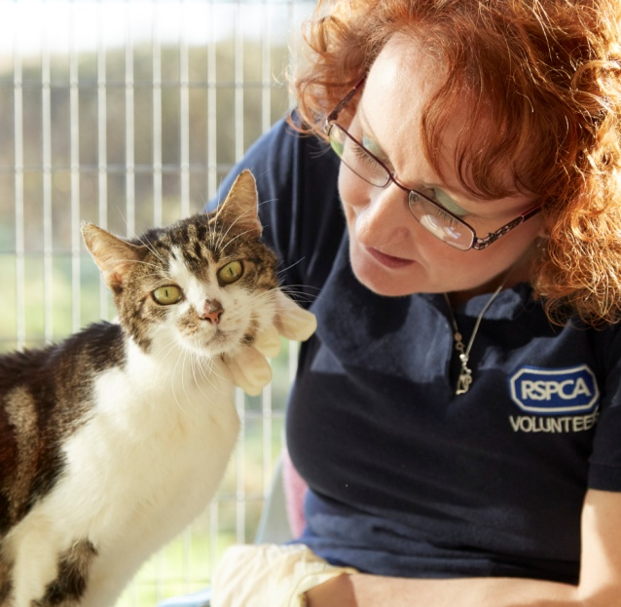
We welcome members of all ages – your support will help us:
- to raise awareness of the welfare needs of our
pets – helping pet owners to make sure those
needs are being met
- to improve the welfare of as many farm animals
as possible, at every stage of their lives
- to ensure that wild animals are protected from unnecessary suffering
- to reduce the use of animals in experiments
and reduce their suffering.
Without the financial support of the public
we simply couldn’t help these animals –
please join us today!

RSPCA adult members receive:
- A membership card and badge.
- A subscription to our magazine animal life.
- An RSPCA sticker for your car or window.
- An annual review of the RSPCA’s work and a financial summary.
- The right to vote individually at the charity’s annual general meeting.
- The right to vote individually for the election of national board members.
Joint membership is open to any two people who are both aged 18 or over and who live together at the same address as partners. Joint members are treated as individuals and both have the right to cancel their membership individually at any time. Joint members will normally receive only one copy of animal life and the annual review sent to their joint address. However, you can ask to receive separate copies of these documents. Requests should be addressed in writing to: The Chief Executive, c/o RSPCA Supporter Services, Wilberforce Way, Southwater, Horsham, West Sussex RH13 9RS or emailed to: supportercare@rspca.org.uk
As a member of the RSPCA you are also entitled to apply to become a member of your local RSPCA branch at no extra cost to you.
Our branches are separately registered, volunteer-run charities and are always grateful for more support in their area – examples of how you can support them are:
- volunteering – from walking dogs, cleaning kennels or assisting in charity shops
- supporting and/or attending local projects such as fun or open days
- branch members with an interest in governance can apply to sit on the local
board of trustees.
Your local branch will contact you should you agree for your details to be passed on to them as a membership request. Ticking the box on the application form will allow us to pass your details on to them.

RSPCA (Society and Branch) Membership is administered by The RSPCA, Wilberforce Way, Southwater, Horsham RH13 9RS. Registered charity number 219099.
Membership application information

MORE INFORMATION – MEMBERSHIP

If you would like information on our animal welfare and membership policies or governing documents (the Society and Branch Rules) they can be found on our website:
www.rspca.org.uk/whatwedo/howwework/policies
www.rspca.org.uk/whatwedo/howwework/rules

Alternatively, please telephone, email or write to our Supporter Services to request a copy of these documents.
Telephone: 0300 123 0346 (Monday to Friday 9am–5pm)
Email: supportercare@rspca.org.uk
RSPCA Supporter Services
Wilberforce Way, Southwater
Horsham, West Sussex RH13 9RS.

YOUR DATA AND HOW WE USE IT

If you wish to change your communication preferences please email: supportercare@rspca.org.uk or call
our Supporter Services Team on 0300 123 0346.
Information on how we use your personal data is set out in our privacy policy, published at www.rspca.org.uk/privacy or you can contact our Supporter Services Team for more Information
on 0300 123 0346.
Please let us know if your address changes so that we can keep your membership up to date.

GIFT AID

It is possible to gift aid your membership subscription. Joint Membership – HMRC does not accept a joint Gift Aid Declaration and each of you will need to complete a separate declaration. Alternatively, a single declaration is acceptable as long as the person completing the declaration is a UK taxpayer and payment is received from their bank account or a joint bank account, where they are one of the named account holders. Please contact us should you require another declaration form.
If you have already completed a declaration please let us know if you want to cancel or amend your declaration,
e.g. if your name or address has changed or if you no longer pay sufficient income tax or capital gains tax. The RSPCA is required by HMRC to hold your current home address to identify you as a UK taxpayer. If we do not have the correct information we may be unable to claim the tax.

The Direct Debit Guarantee This guarantee should be retained by the payer.
- This Guarantee is offered by all Banks and Building Societies that accept instructions to pay by Direct Debit.
- If there are any changes to the amount, date or frequency of your Direct Debit the RSPCA will notify you at least
10 working days in advance of your account being debited or as otherwise agreed. If you request the RSPCA to
collect a payment the time of the request.
- If an error is made in the payment of your Direct Debit by the RSPCA or your bank or building society, you are
entitled to a full and immediate refund of the amount paid from your bank or building society.
If you receive a refund you are not entitled to, you must pay it back when the RSPCA asks you to.
- You can cancel a Direct Debit at any time by simply contacting your bank or building society. Written confirmation
may be required. Please also notify the RSPCA.

Adult membership application form

Please return your completed form to: RSPCA Membership Supervisor, Supporter Services Team, Wilberforce Way, Southwater, Horsham, West Sussex RH13 9RS.
MEMBERSHIP TYPE: Individual annual £24.00 Joint annual £36.00 Individual life £750.00 Joint life £1,000.00

MEMBER DETAILS – APPLICANT 1
Title: |  | First name: |  | Surname:

Date of birth (optional) |  |  |  |  |  | / |  |  |  | / |  |  |  |  |  |  |  |  | Telephone/mobile:
Email:
Declaration
I support the objects of the RSPCA to promote kindness and to prevent or suppress cruelty to animals by all lawful means. I acknowledge that
my application/membership of the Society, is governed in accordance with the RSPCA Rules. I confirm I am over 18 years old.

Signed |  |  |  |  |  |  |  |  |  |  |  |  |  |  |  |  |  |  |  | Date |  |  |  |  | / |  |  |  | / | 2 |  | 0

Your membership subscription entitles you to a membership card, badge, a subscription to animal life magazine as well as an invitation and voting papers for the AGM. These materials are subject to change without prior notice. I am happy to receive membership material/updates by email
We’d love to keep you updated about our work. This may include supporter magazines and updates, appeals and fundraising activities, volunteering, animal welfare campaigning, shop products and other services. Your details will only be used by the RSPCA – we’ll never share your information with other organisations to use for their own marketing purposes. Please tell us how you would like to hear from us.
Email SMS Phone Post
We would like to forward your name and contact details to your local branch, which is a separate volunteer-run charity, so that they can consider you for branch membership and contact you on how you may be able to assist them. Your application for membership is governed by the Branch Rules. As each RSPCA branch is a registered charity in its own right, they will advise you separately of their privacy policies and how they manage your data.
Yes, I agree for my details to be sent to my local RSPCA branch. (Please do not tick if you are employed by the RSPCA or a branch as branch rules prevent you from being a member of a branch.)

MEMBER DETAILS – APPLICANT 2 (joint membership is £36.00 for 12 months)
Title: |  | First name: |  | Surname:

Date of birth (optional) |  |  |  |  |  | / |  |  |  | / |  |  |  |  |  |  |  |  | Telephone/mobile:
Email:
Declaration
I support the objects of the RSPCA to promote kindness and to prevent or suppress cruelty to animals by all lawful means. I acknowledge that
my application/membership of the Society, is governed in accordance with the RSPCA Rules. I confirm I am over 18 years old.

Signed |  |  |  |  |  |  |  |  |  |  |  |  |  |  |  |  |  |  |  | Date |  |  |  |  | / |  |  |  | / | 2 |  | 0

Your membership subscription entitles you to a membership card, badge, a subscription to animal life magazine as well as an invitation and voting papers for the AGM. These materials are subject to change without prior notice. I am happy to receive membership material/updates by email
We’d love to keep you updated about our work. This may include supporter magazines and updates, appeals and fundraising activities, volunteering, animal welfare campaigning, shop products and other services. Your details will only be used by the RSPCA – we’ll never share your information with other organisations to use for their own marketing purposes. Please tell us how you would like to hear from us.
Email SMS Phone Post
We would like to forward your name and contact details to your local branch, which is a separate volunteer-run charity, so that they can consider you for branch membership and contact you on how you may be able to assist them. Your application for membership is governed by the Branch Rules. As each RSPCA branch is a registered charity in its own right, they will advise you separately of their privacy policies and how they manage your data.
Yes, I agree for my details to be sent to my local RSPCA branch. (Please do not tick if you are employed by the RSPCA or a branch as branch rules prevent you from being a member of a branch.)

ADDRESS DETAILS

The address supplied applies to both joint applicants.
Address:
Town: |  |  |  |  |  | County: |  |  |  | Postcode:
PAYMENT DETAILS
Membership fee: |  | Individual annual/£24.00 Joint annual/£36.00 Individual life/£750.00 Joint life/£1,000.00
Additional donation of: |  |  | £ |  | to be donated to: |  |  |  | Where support is most needed My local RSPCA branch
Making my payment a total amount of: |  |  |  | £ |  |  | (Not applicable if completing the Direct Debit section)

BY CHEQUE Please make cheques payable to RSPCA

Credit/debit card
Card type | Visa Mastercard CAF (We do not accept American Express) | Card name

Card number

Valid from date: |  |  |  | / |  |  |  | Expiry date: |  |  |  | / |  |  |  | Issue number:

Signed |  | Date: |  |  |  | / |  |  |  | / | 2 |  | 0

DIRECT DEBIT INSTRUCTION
I would like to pay my RSPCA membership subscription by continuous Direct Debit instruction.
I would like to pay Annually Monthly (please tick) on the 3rd 15th 22nd 28th (please tick preferred date)
Membership fee: | Individual/£24.00 Joint/£36.00
Please complete the form below:

Instruction to your Bank or Building Society to pay by Direct Debit
Service User Number: 768136
 | To the manager (your bank’s name):
 | Bank address: |  |  |  |  |  |  |  |  |  |  |  |  |  |  |  |  |  |  |  |  |  | Postcode:
 | Name(s) of account holder(s):
 | Sort code: |  |  |  |  |  |  | — |  |  |  |  | — |  |  | Account no:
 | Reference number: |  |  |  |  |  |  |  |  |  |  |  |  |  |  |  |  | (for office use only)
Please pay the RSPCA Direct Debits from the account detailed on this instruction, subject to the safeguards assured by
the Direct Debit Guarantee. I understand that this instruction may remain with the RSPCA and, if so, details will be passed
electronically to my bank/building society.
 | Signature(s) Date / / 2 0

GIFT AID – PLEASE ALLOW THE RSPCA TO BOOST YOUR DONATION BY 25p for every £1 you donate
Gift Aid is a simple, tax efficient way of making your donation go further. If you are a UK taxpayer, then the
RSPCA can reclaim the basic rate of tax on your donations. Please complete the section below to include the
name of the individual against which the Gift Aid Declaration will be registered.*
Title: |  |  | First name: |  | Surname:
In order to Gift Aid your donations you must tick the box below. ()
YES, I am a UK taxpayer and would like the RSPCA to treat any donations I make in the future and have made in the past four
years as Gift Aid donations, until I notify you otherwise. I understand that if I pay less Income Tax and/or Capital Gains Tax
than the amount of Gift Aid claimed on all my donations in that tax year it is my responsibility to pay any difference.

Date: |  |  |  | / |  |  |  | / | 2 |  | 0

* Joint declarations cannot be made. Please contact us if you require another declaration.

